Crossed Heptagrammic Cuploid

Definition
# Source: AI Source: Provided by: [Data Path: Persons Table -> ID Column: 1, Name_En Column: Motasem Essam] -> From: [ChatGPT] on [7/25/2026]
A Crossed Heptagrammic Cuploid, also known as a $\{7/4\}$-Cuploid, is a specialized non-orientable polyhedral construction belonging to the cuploid family.
It is based on a seven-vertex star-polygon arrangement in which each vertex is connected to the vertex four positions ahead. Its triangular and square faces form a crossed arrangement.
The corresponding lower polygonal base is degenerate and is removed, allowing the triangular and square faces to connect directly. Unlike the Heptagrammic Cuploid $\{7/2\}$, it does not require a separate central membrane.
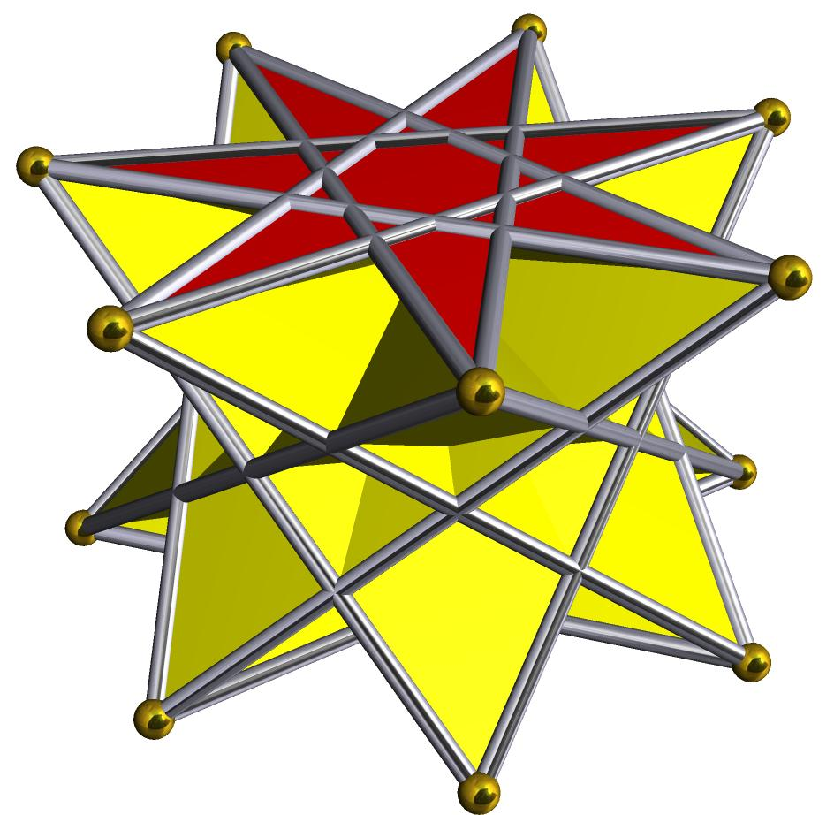

Simple Definition
# Source: AI Source: Provided by: [Data Path: Persons Table -> ID Column: 1, Name_En Column: Motasem Essam] -> From: [ChatGPT] on [7/25/2026]
A Crossed Heptagrammic Cuploid is a three-dimensional non-orientable geometric structure based on a seven-vertex crossed star arrangement, with triangular and square faces and no ordinary lower polygonal base.

Geometric Structure
# Source: AI Source: Provided by: [Data Path: Persons Table -> ID Column: 1, Name_En Column: Motasem Essam] -> From: [ChatGPT] on [7/25/2026]
Its star-polygon notation is:
$$\boxed{\{7/4\}}$$
This notation means:
- 7 represents the seven vertices.
- 4 represents the step size used to connect the vertices.
- Each vertex connects to the vertex four positions ahead.
- The resulting arrangement is a retrograde heptagram.
- The corresponding lower polygonal base is degenerate and is removed.
- The triangular and square faces connect directly along the resulting boundary.
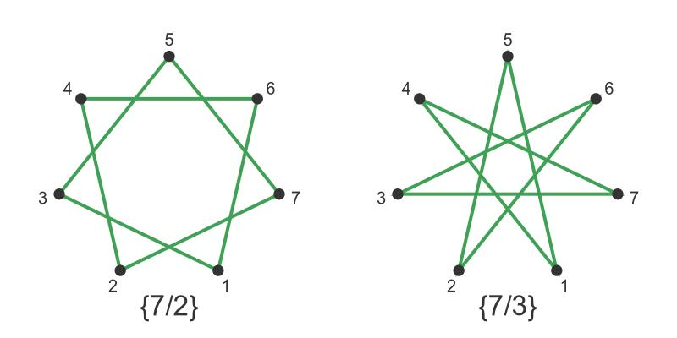

Face Structure
# Source: AI Source: Provided by: [Data Path: Persons Table -> ID Column: 1, Name_En Column: Motasem Essam] -> From: [ChatGPT] on [7/25/2026]
The standard Crossed Heptagrammic Cuploid has 15 faces:
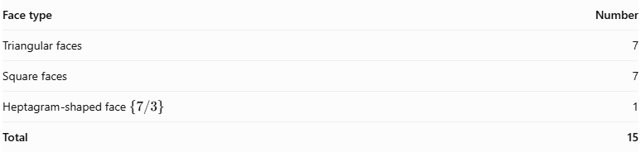
Face type | Number
Triangular faces | 7
Square faces | 7
Heptagram-shaped face $\{7/3\}$ | 1
Total | 15
The seven triangular and seven square faces form the lateral structure. The upper face is a heptagram with the geometry $\{7/3\}$.

Edge Structure
# Source: AI Source: Provided by: [Data Path: Persons Table -> ID Column: 1, Name_En Column: Motasem Essam] -> From: [ChatGPT] on [7/25/2026]
In its standard realization, it has:
- 28 edges.
- Seven edges along the upper heptagram boundary.
- Edges connecting the triangular and square faces.
- A crossed arrangement resulting from the retrograde construction.
The lower polygonal base is not retained as a separate face.

Vertex Structure
# Source: AI Source: Provided by: [Data Path: Persons Table -> ID Column: 1, Name_En Column: Motasem Essam] -> From: [ChatGPT] on [7/25/2026]
The standard realization has 14 vertices.
- Seven vertices are associated with the upper heptagram.
- Seven additional vertices form the lower connections.
- The vertices connect the triangular and square faces.

Mathematical Properties
# Source: AI Source: Provided by: [Data Path: Persons Table -> ID Column: 1, Name_En Column: Motasem Essam] -> From: [ChatGPT] on [7/25/2026]
Geometric data
15
Faces
28
Edges
14
Vertices
Euler characteristic:
$$V-E+F=14-28+15=1$$
The Euler characteristic of 1 is consistent with a non-orientable projective-plane surface.

Why It Does Not Have a Membrane
# Source: AI Source: Provided by: [Data Path: Persons Table -> ID Column: 1, Name_En Column: Motasem Essam] -> From: [ChatGPT] on [7/25/2026]
The Crossed Heptagrammic Cuploid does not require a separate central membrane.
- Its notation is $\{7/4\}$.
- The ratio is $7/4=1.75$, which is less than 2.
- Its triangular and square faces cover the relevant lower region.
- Therefore, no additional membrane is needed.
This distinguishes it from the Heptagrammic Cuploid $\{7/2\}$, which has a membrane.
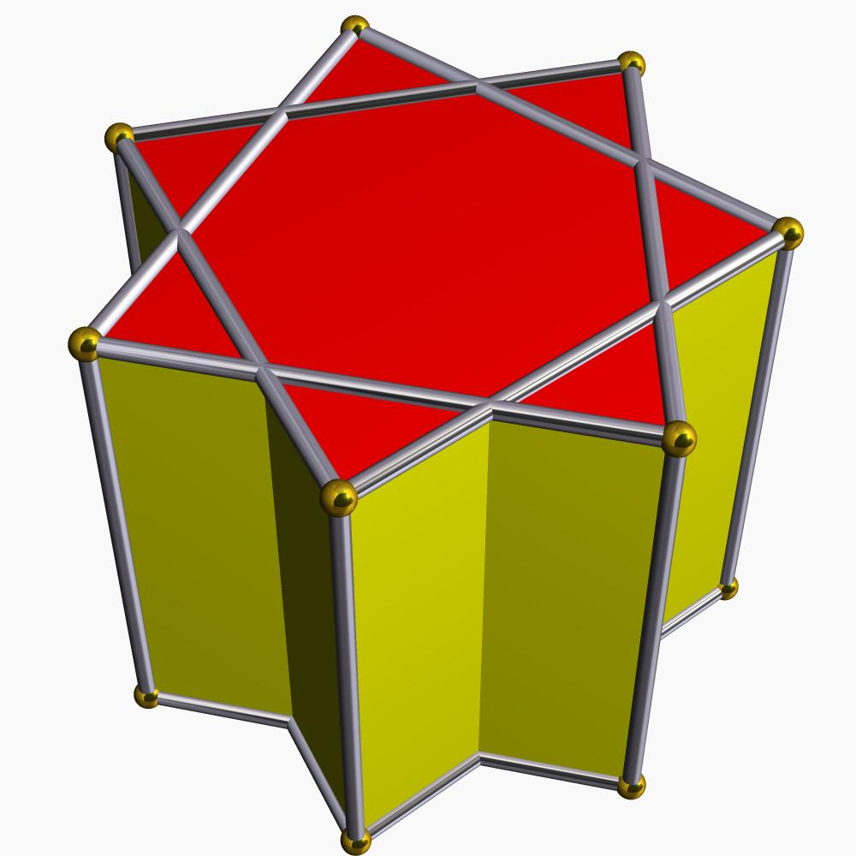
Heptagrammic Cuploid
Has membrane
$$\{7/2\}$$
Crossed Heptagrammic Cuploid
No membrane
$$\{7/4\}$$

Symmetry
# Source: AI Source: Provided by: [Data Path: Persons Table -> ID Column: 1, Name_En Column: Motasem Essam] -> From: [ChatGPT] on [7/25/2026]
In its regular symmetric realization, the Crossed Heptagrammic Cuploid has:
- Sevenfold rotational symmetry.
- Seven vertical reflection symmetries.
- A sevenfold dihedral symmetry arrangement.
These symmetries arise from its sevenfold star-polygon construction.

Relationship to Other Solids
# Source: AI Source: Provided by: [Data Path: Persons Table -> ID Column: 1, Name_En Column: Motasem Essam] -> From: [ChatGPT] on [7/25/2026]
The Crossed Heptagrammic Cuploid belongs to the family of star-cuploids.
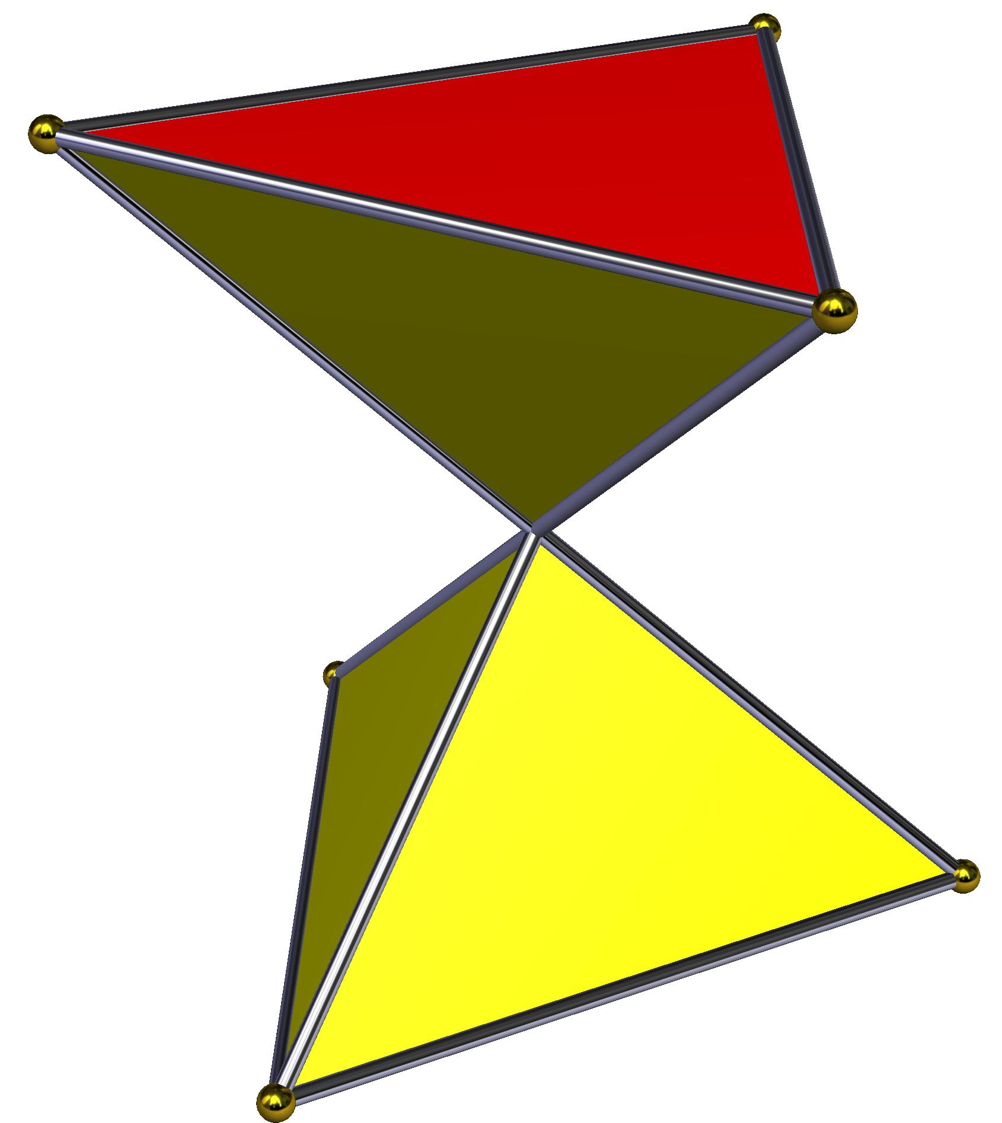
Crossed Triangular Cuploid
$$\{3/2\}$$
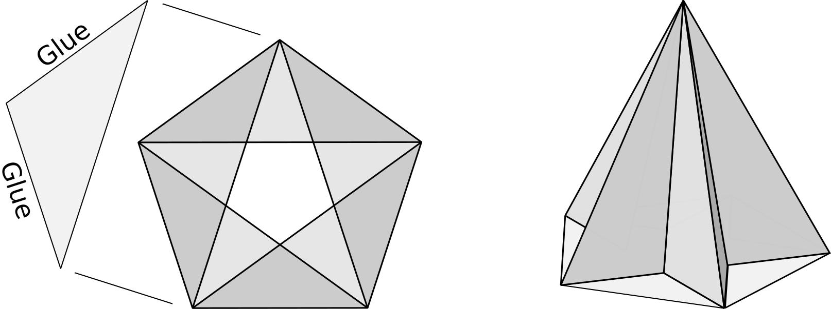
Pentagrammic Cuploid
$$\{5/2\}$$
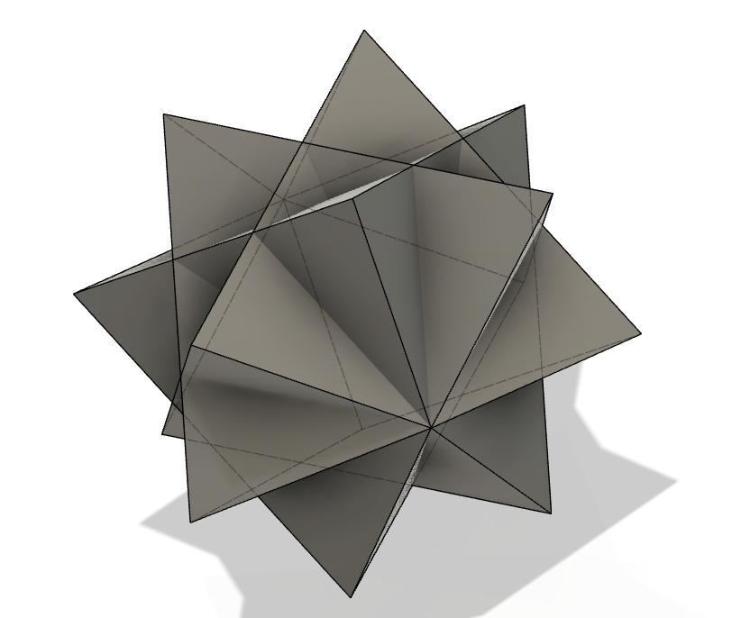
Heptagrammic Cuploid
$$\{7/2\}$$
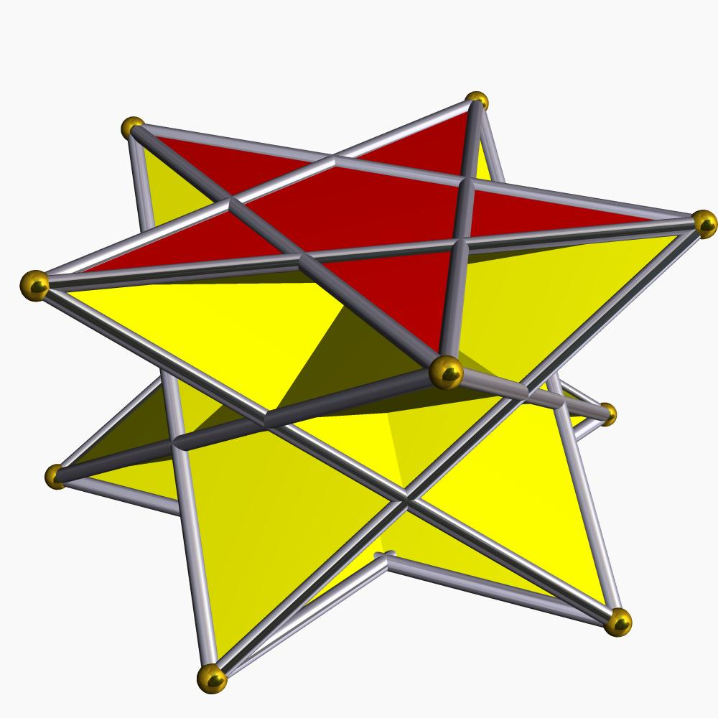
Crossed Pentagonal Cuploid
$$\{5/4\}$$
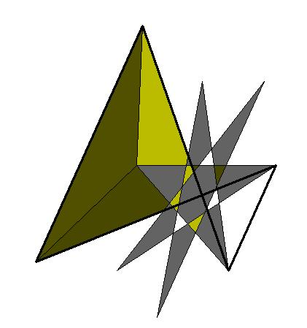
Crossed Heptagrammic Cuploid
$$\{7/4\}$$

Construction of a Crossed Heptagrammic Cuploid

Geometric Instruments Used
# Source: AI Source: Provided by: [Data Path: Persons Table -> ID Column: 1, Name_En Column: Motasem Essam] -> From: [ChatGPT] on [7/25/2026]
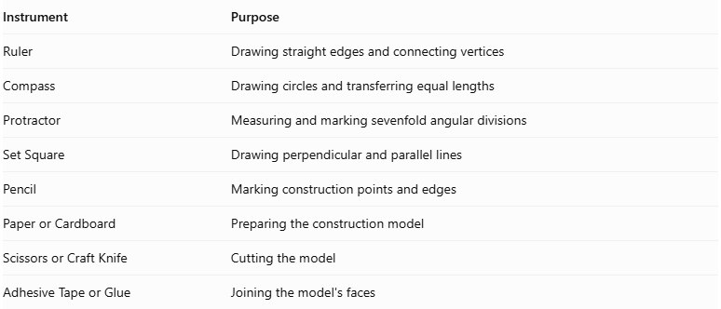
Instrument | Purpose
Ruler | Drawing straight edges and connecting vertices
Compass | Drawing circles and transferring equal lengths
Protractor | Measuring and marking sevenfold angular divisions
Set Square | Drawing perpendicular and parallel lines
Pencil | Marking construction points and edges
Paper or Cardboard | Preparing the construction model
Scissors or Craft Knife | Cutting the model
Adhesive Tape or Glue | Joining the model's faces
Construction note: A regular heptagon cannot be constructed exactly using only an unmarked straightedge and compass. A protractor or another suitable angle-measuring instrument can be used for a measured construction.

Instrument-Based Construction Procedures

Constructing the Heptagrammic Face
# Source: AI Source: Provided by: [Data Path: Persons Table -> ID Column: 1, Name_En Column: Motasem Essam] -> From: [ChatGPT] on [7/25/2026]
- Draw a circle using a compass.
- Mark seven approximately equally spaced points around its circumference using a protractor.
- Label the points $A,B,C,D,E,F,G$ in circular order.
- Connect every fourth vertex to form the $\{7/4\}$ heptagram.
- Check that the seven connections form the intended crossed star arrangement.
The angular interval between consecutive vertices is:
$$θ=\frac{{360}^{°}}{7}$$
$$θ≈{51.4286}^{°}$$
The connection advances four vertex positions:
$$4θ≈{205.7143}^{°}$$

Constructing the Seven Square Faces
# Source: AI Source: Provided by: [Data Path: Persons Table -> ID Column: 1, Name_En Column: Motasem Essam] -> From: [ChatGPT] on [7/25/2026]
- Prepare seven square faces with matching edge lengths.
- Arrange them around the heptagrammic structure according to the cuploid's face-adjacency pattern.
- Match their edges to the appropriate triangular and star-polygon boundaries.
- Check that the squares follow the sevenfold arrangement.

Constructing the Seven Triangular Faces
# Source: AI Source: Provided by: [Data Path: Persons Table -> ID Column: 1, Name_En Column: Motasem Essam] -> From: [ChatGPT] on [7/25/2026]
- Prepare seven triangular faces.
- Match their edges to the corresponding square-face boundaries.
- Arrange the triangles between the appropriate square connections.
- Check that each triangular face follows the intended neighboring-face connections.

Connecting the Faces
# Source: AI Source: Provided by: [Data Path: Persons Table -> ID Column: 1, Name_En Column: Motasem Essam] -> From: [ChatGPT] on [7/25/2026]
- Arrange the heptagrammic, square, and triangular faces according to the Crossed Heptagrammic Cuploid structure.
- Identify the degenerate $\{14/4\}$ base arrangement.
- Withdraw this degenerate base instead of constructing it as an ordinary polygonal face.
- Connect the triangular faces directly to the square faces along their corresponding edges.
- Preserve the crossed heptagrammic arrangement.
- Verify the intended face adjacency throughout the structure.

Completing the Solid Drawing
# Source: AI Source: Provided by: [Data Path: Persons Table -> ID Column: 1, Name_En Column: Motasem Essam] -> From: [ChatGPT] on [7/25/2026]
- Draw visible edges using continuous lines.
- Draw hidden edges using dashed lines where appropriate.
- Distinguish the heptagrammic, triangular, and square faces.
- Check the sevenfold symmetry.
- Inspect the structure for missing or incorrectly joined edges.
Construction note: The cuploid is non-orientable. A physical model or drawing must therefore represent its self-intersecting arrangement appropriately; it should not be treated as an ordinary closed, convex polyhedron.

Key Points
# Source: AI Source: Provided by: [Data Path: Persons Table -> ID Column: 1, Name_En Column: Motasem Essam] -> From: [ChatGPT] on [7/25/2026]
- The Crossed Heptagrammic Cuploid is represented by $\{7/4\}$.
- It is also known as the $\{7/4\}$-Semicupola.
- It belongs to the star-cuploid family.
- It has seven triangular faces.
- It has seven square faces.
- It has one upper heptagram-shaped face.
- It has 15 faces, 28 edges, and 14 vertices.
- It is non-orientable.
- It does not require a separate central membrane.
- It is different from the Heptagrammic Cuploid $\{7/2\}$.

Conclusion
# Source: AI Source: Provided by: [Data Path: Persons Table -> ID Column: 1, Name_En Column: Motasem Essam] -> From: [ChatGPT] on [7/25/2026]
The Crossed Heptagrammic Cuploid is a specialized non-orientable polyhedral construction based on a seven-vertex retrograde star-polygon arrangement. Its combination of triangular faces, square faces, and a heptagram-shaped upper face makes it an interesting example of advanced solid geometry and polyhedral topology.
Geometric clarification: The $\{7/4\}$ notation describes the retrograde traversal. As an undirected star-polygon outline, it corresponds to $\{7/3\}$. This is why the upper face is described as a $\{7/3\}$ heptagram.

